**NAME:SRIVATHSAN N**

**ROLL NO:230701343**

**CSE-F**

**DESIGN OF ANALYSIS AND ALGORITHMS**

# WEEK 1: BASIC C - PROGRAMMING PRACTICE

### PROGRAM 1:

**AIM:** Given 2 numbers, write a program to swap them.

### ALGORITHM:

Step 1: Initialize a,b,temp as int

Step 2: Input numbers from user for a and b Step 3: Perform temp=a, a=b, b=temp

Step 4: Display the number

### PROGRAM:

#include<stdio.h> int main()

{

int a,b,temp; scanf("%d %d",&a,&b); temp=a;

a=b; b=temp;

printf("%d %d",a,b);

}

### OUTPUT:

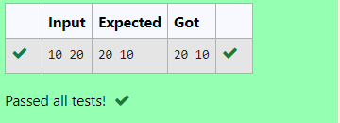

**RESULT:** Thus, the program is executed successfully.

### PROGRAM 2:

**AIM:** Write a program to find the eligibility of admission for a professional course based on the following criteria:

Marks in Math >= 65

Marks in Physics >= 55 [or] Total in all subjects >=180 Marks in Chemistry >= 50

### ALGORITHM:

Step 1: Initialize m as math, p as physics, c as chemistry all as int datatype. Step 2: Input 3 numbers out of 100 from the user.

Step 3: Check if m>=65 and p>=55 and c>=50 →Then display “the candidate is eligible” Or check if m+p+c>=180 → Then display “the candidate is eligible”

Else → Display “the candidate is not eligible”

### PROGRAM:

#include<stdio.h> int main()

{

int m,p,c; scanf("%d%d%d",&m,&p,&c);

if (m>=65 && p>=55 && c>=50){ printf("The candidate is eligible");

}else if(m+p+c>=180){

printf("The candidate is eligible");

}else{

printf("The candidate is not eligible");

}}

### OUTPUT:

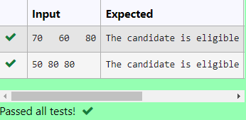

**RESULT:** Thus, the program is executed successfully.

### PROGRAM 3:

**AIM:** Malini goes to Best save hyper market to buy grocery items. Bestsave hypermarket provides 10% discount on the bill amount B whenever the bill amount B is more than Rs. 2000. The bill amount B is passed as the input to the program and it must print the final amount payable by Malini.

### ALGORITHM:

Step 1: Initialize the payment and the discount as integer data types. Step 2: Take an input for payment from the user.

Step 3: Check if payment > 2000, → calculate discount as payment*0.10 and subtract it from the original payment amount.

Display the new payment.

Step 4: Else → display the payment amount.

### PROGRAM:

#include<stdio.h> int main()

{

int pay,disc; scanf("%d",&pay); if (pay>2000){

disc=pay*0.10; pay=pay-disc; printf("%d",pay);

}else{

printf("%d",pay);

}

}

### OUTPUT:

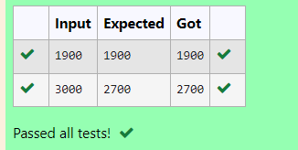

**RESULT:** Thus, the program is executed successfully.

### PROGRAM 4:

**AIM:** Baba is very kind to beggars and every day Baba donates half of the amount he has whenever a beggar requests him. The money m left in Baba’s hand is passed as the input and the number of beggars B who received the alms are passed as the input. The program must print the money Baba had at the beginning of the day.

### ALGORITHM:

Step 1: Initialize m and n as integer data types symbolizing the money and the number of beggars.

Step 2: Take an input from the user for the number of beggars and the money amount. Step 3: Initialize the for loop until n, and multiply the money as money=money * n Step 4: Outside the loop display the amount m symbolizing the money in hand.

### PROGRAM:

#include<stdio.h> int main()

{

int m,n; scanf("%d%d",&m,&n); for (int i=0;i<n;i++)

{

m=m*n;

}

printf("%d",m);

}

### OUTPUT:

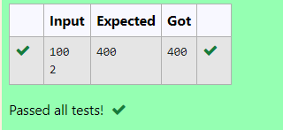

**RESULT:** Thus, the program is executed successfully.

### PROGRAM 5:

**AIM:** The CEO of company ABC inc wanted to encourage the employees coming on time to the office so he announced that for every consecutive day an employee comes on time [starting from Monday through Saturday] he will be awarded Rs. 200 more than the previous day as “Punctuality incentive”. Incentive for starting day is passed as input and the number of days N is also passed. The program is to calculate the “Punctuality incentive” P of the employee.

### ALGORITHM:

Step 1: Initialize incentive i, n number of days and sum as integer datatype Step 2: Take an input from the user for incentive and number of days i and n. Step 3: initialize the sum as i, and initiate a for loop till n-1;

Within this for loop, calculate incentive as incentive + 200 and the sum + incentive. Step 4: Outside the loop, display the sum.

### PROGRAM:

#include<stdio.h> int main()

{

int i,n,sum; scanf("%d%d",&i,&n); sum=i;

for (int j=1;j<n;j++){ i=i+200;

sum+=i;

}printf("%d",sum);

}

### OUTPUT:

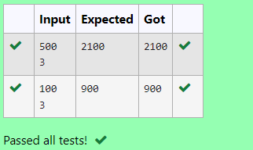

**RESULT:** Thus, the program is executed successfully.

### PROGRAM 6:

**AIM:** Two numbers a and b are passed as the input. A number x is also passed as the input. The program must print the numbers divisible by x from b to a range inclusive of a and b.

### ALGORITHM:

Step 1: Initialize the numbers as a, b, c as integer data types. Step 2: Take an input for a, b and c from the user.

Step 3: In a for loop, >=a, decrementing the value, Check if i%c==0, → Display the number i

Else → continue

### PROGRAM:

#include<stdio.h> int main()

{

int a,b,c; scanf("%d%d%d",&a,&b,&c); for (int i=b;i>=a;i--)

{

if(i%c==0)

{

printf("%d ",i);

}

else continue;

}

}

### OUTPUT:

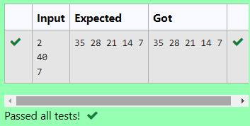

**RESULT:** Thus, the program is executed successfully.

### PROGRAM 7:

**AIM:** Write a program to find the quotient and remainder of the given integers.

### ALGORITHM:

Step 1: Initialize the 2 numbers a and b.

Step 2: Take an input for a and b from the user. Step 3: Display a/b and a%b.

### PROGRAM:

#include<stdio.h> int main()

{

int a,b; scanf("%d%d",&a,&b);

printf("%d\n",a/b);

printf("%d",a%b);

}

### OUTPUT:

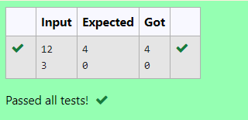

**RESULT:** Thus, the program is executed successfully.

### PROGRAM 8:

**AIM:** Write a program to find the biggest number out of the 3 given integers.

### ALGORITHM:

Step 1: Initialize the 3 numbers as a, b, c as integer data types. Step 2: Take an input from the a, b, c.

Step 3: Check if a>b and a>c → Display a Else check if b>a and b>c → Display b Else check if c>a and c>b → Display c

### PROGRAM:

#include<stdio.h> int main()

{

int a,b,c; scanf("%d%d%d",&a,&b,&c); if (a>b && a>c)

printf("%d",a); else if (b>a && b>c)

printf("%d",b); else if (c>a && c>b)

printf("%d",c);

}

### OUTPUT:

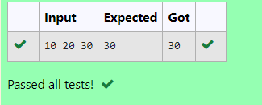

**RESULT:** Thus, the program is executed successfully.

### PROGRAM 9:

**AIM:** Write a C program to find whether the given number is odd or even.

### ALGORITHM:

Step 1: Initialize a number M as integer data type. Step 2: Take an input from the user.

Step 3: Check if m%2==0 → Display even Else → Display odd.

### PROGRAM:

#include<stdio.h> int main()

{

int m; scanf("%d",&m); if (m%2==0) printf("Even"); else printf("Odd");

}

### OUTPUT:

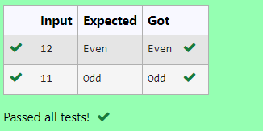

**RESULT:** Thus, the program is executed successfully.

### PROGRAM 10:

**AIM:** Write a C program to find the factorial of a number N.

### ALGORITHM:

Step 1: Initialize x , i and factorial=1 as integer data type. Step 2: Take an input for x.

Step 3: In a for loop, as i=1, and i<=x Calculate fact*=i

Step 4: Display the factorial.

### PROGRAM:

#include<stdio.h> int main()

{

int x,i,fact=1; scanf("%d",&x); for (i=1;i<=x;i++)

fact*=i; printf("%d",fact);

}

### OUTPUT:

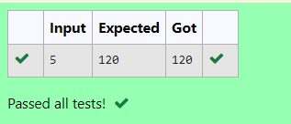

**RESULT:** Thus, the program is executed successfully.

### PROGRAM 11:

**AIM:** Write a C program to find the sum of first N natural.

### ALGORITHM:

Step 1: Initialize x and sum=0 as integer data type. Step 2: Take an input for x from the user.

Step 3: In a for loop, i=1, i<=x, Calculate sum+=i Step 4: Display sum.

### PROGRAM:

#include<stdio.h> int main()

{

int x,sum=0; scanf("%d",&x);

for (int i=1;i<=x;i++)

{

sum+=i;

}

printf("%d",sum);

}

### OUTPUT:

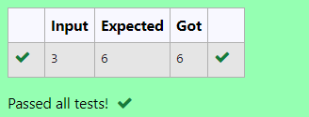

**RESULT:** Thus, the program is executed successfully.

### PROGRAM 12:

**AIM:** Write a C program to find the Nth term in the fibonacci series.

### ALGORITHM:

Step 1: Initialize n, f0=0, f1=1, f2 and z=0, o=1 as integer data type. Step 2: Take an input for n.

Step 3: Check if n==0, → Display z Else if n==1 → Display 0

Else calculate f2=f1+f0, f0=f1 and f1=f2 within a for loop Step 4: Display f2.

### PROGRAM:

#include<stdio.h> int main()

{

int n,f0=0,f1=1,f2,z=0,o=1; scanf("%d",&n);

if(n==0) printf("%d",z);

else if(n==1) printf("%d",o); else{

for(int i=1;i<n;i++){ f2=f1+f0;

f0=f1; f1=f2;

}printf("%d",f2);

}}

### OUTPUT:

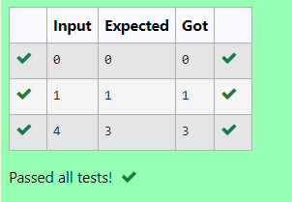

**RESULT:** Thus, the program is executed successfully.

### PROGRAM 13:

**AIM:** Write a C program to find the powers of integers.

### ALGORITHM:

Step 1: Initialize y, x and p as integers.

Step 2: Take an input from the user for x and y. Step 3: calculate p as p=pow(x,y) and display p.

### PROGRAM:

#include<stdio.h> #include<math.h> int main()

{

int y,x,p; scanf("%d%d",&x,&y); p=pow(x,y); printf("%d",p);

}

### OUTPUT:

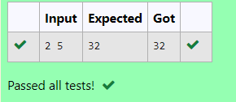

**RESULT:** Thus, the program is executed successfully.

### PROGRAM 14:

**AIM:** Write a C program to find whether the integer is prime or not.

### ALGORITHM:

Step 1: Initialize m as integer. Step 2: Take an input for m.

Step 3: Check if m%2!=0 and m%3!=0 and m%5!=0 → Display prime Else → display not prime.

### PROGRAM:

#include<stdio.h> int main()

{

int m; scanf("%d",&m);

if (m%2!=0 && m%3!=0 && m%5!=0)

{

printf("Prime");

}

else

{

printf("No Prime");

}

}

### OUTPUT:

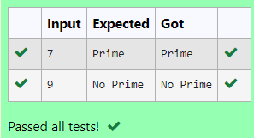

**RESULT:** Thus, the program is executed successfully.

### PROGRAM 15:

**AIM:** Write a C program to find reverse of integer

### ALGORITHM:

Step 1: Initialize m, rev=0 and rem as integers. Step 2: Take an input for m

Step 3: While m!=0 → rem=n%10 rev=rev*10+rem and m/=10 Step 4: Display rev

### PROGRAM:

#include<stdio.h> int main()

{

int m,rev=0,rem; scanf("%d",&m); while(m!=0)

{

rem=m%10; rev=rev*10+rem; m/=10;

}

printf("%d",rev);

}

### OUTPUT:

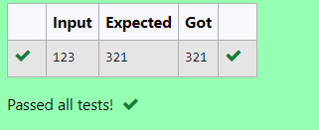

**RESULT:** Thus, the program is executed successfully.